Philadelphia University
Faculty of Information Technology Department of Software Engineering
Examination Paper
Lecturer : Ms. Enas Naffar
Coordinator : Ms. Enas Naffar
Internal Examiner : Dr. Moayad Adhami

Course Name: Software Modeling (721222) Sections: 1
First Exam
First Semester
Academic Year: 2015/2016 Date: November, 24th , 2015 Time: 50 minutes

Information for Candidates
- This examination paper contains 3 questions, totaling 20 marks.
- The marks for parts of questions are shown in round brackets.

Advice to Candidates
1. You should write your answers precisely, clearly and to the point.
2. Draw clear and large model .

I. Basic Notions
Objectives. The aim of the question in this part is to evaluate the required minimal student knowledge and skills. Answers in the pass category represent the minimum acceptable standard.

Question1: (8 marks, 1 mark each)
Choose the correct answer for the following MCQs:

1- Modeling is an intellectual activity that requires:
- Abstraction capabilities
- Separation of concern capabilities
- A and B
- None of the above

2- Which of the following is not a modeling view:
- Structural view
- Anatomy view
- Behavioral view
- Interaction view

3- What is the Unified Modeling Language?
A. A programming language for describing object-oriented models.
B. A diagramming tool for drawing object-oriented models.
C. A graphical language for describing object-oriented models.
D. A standardized graphical language and notation for describing object oriented models

4- What is meant by the multiplicity of an association?
A. The number of associations in a class
B. The number of associations between two classes
C. How many instances of one class relate to how many instances of another class
D. How many instances of one class relate to a single instance of another class.

5- What is an association class?
A. A class with multiple associations
B. A class with one association
C. A class that models an association between two or more classes
D. A class that models an association between two or more objects

6- The class diagram associated with the following object diagram is:
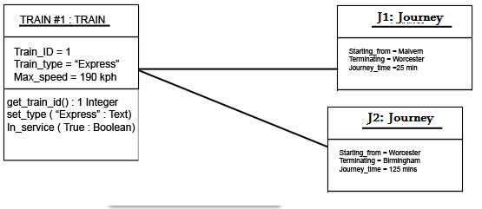
A.
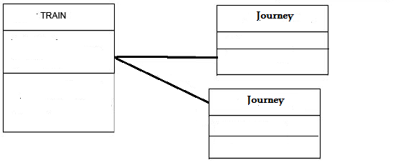
B.
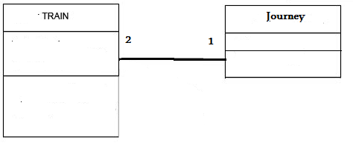
C.
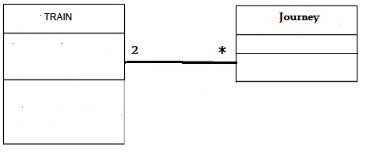

D.
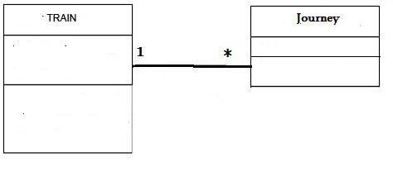

II. Familiar Problems Solving
Objectives. The aim of the question in this part is to evaluate that the student has some basic knowledge of the key aspects of the lecture material and can attempt to solve familiar problems.

Question2: (11 marks)
Consider a university library system that allows borrowers to borrow book copies. A Book usually has more than one copy, but some rare books have only one copy. A book copy is borrowed by one borrower at a time.

Users can search for books based on their title, author or publisher. When a book is found, copy's number, copy's code (that will be used for circulating and returning the copy) , status (whether the copy is available, reserved or borrowed) and location are being displayed to users to facilitate borrowing that copy.

Suppose you have the following three classes : Book, Copy and Borrower

Purpose: borrowing book copies

A- Give two relevant attributes for class Copy, that have basic data types . Specify the name and the type . (2 marks)
Copy_number : number
Copy_code: Text
Location : Text

B- Give one relevant attribute for class Copy , that has a complex data type. Specify the name and the type . (1 mark)
status: available | borrowed| reserved

C- Give two relevant operations for class Copy (2 marks)
Get_location( ) : Text
Get_status( ): available | borrowed| reserved

D- Draw a UML class diagram using the three classes above (6 marks)

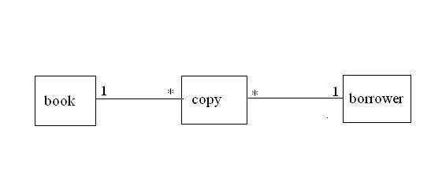

III. Unfamiliar Problems Solving
Objectives. The aim of the question in this part is to evaluate that the student has some basic knowledge of the key aspects of the lecture material and can attempt to solve unfamiliar problems.

Question3: (3 marks, 1 mark each)
Back to Question 2; an association class is needed to be added to the UML class diagram created earlier:

1- Give one relevant attribute for this class
Data_of_borrowing

2- Give one relevant operation for this class
Circulate_copy( )

3- Add the class to the UML diagram in Question 2 (class name + one attribute + one operation) .

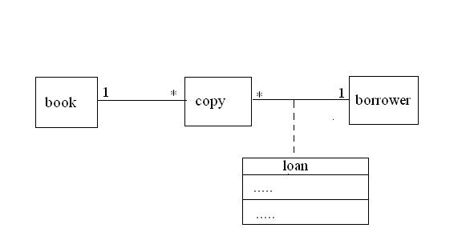

Best of Luck :)

